Simulation results:

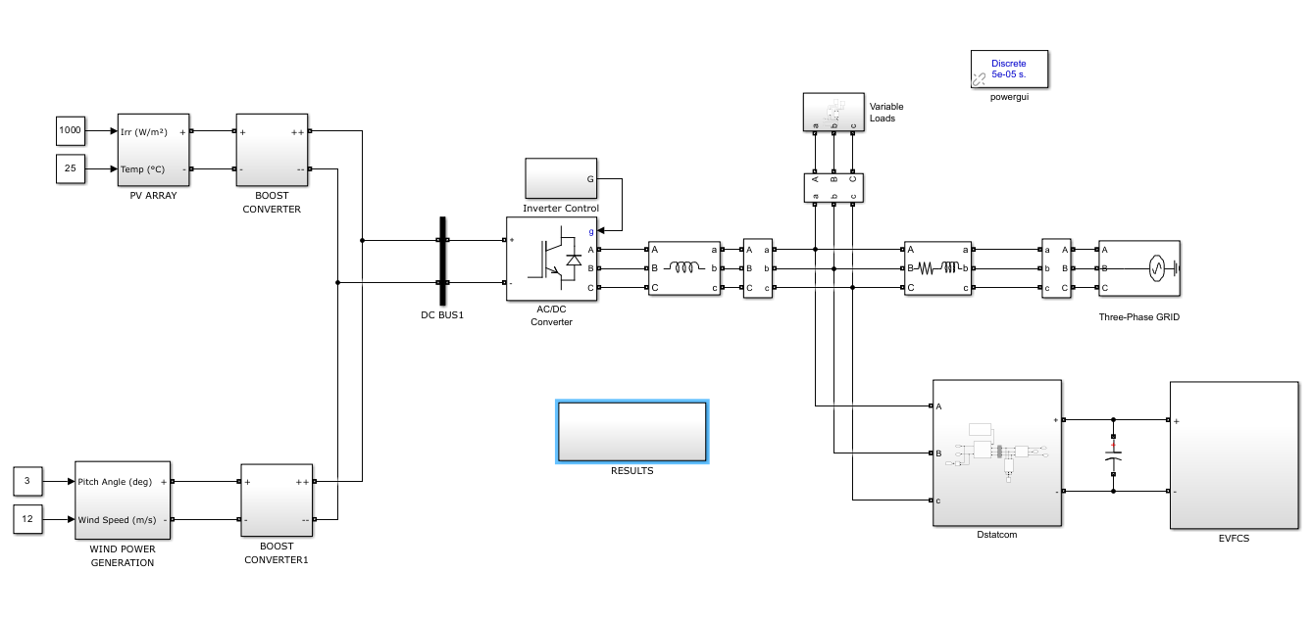
Block diagram
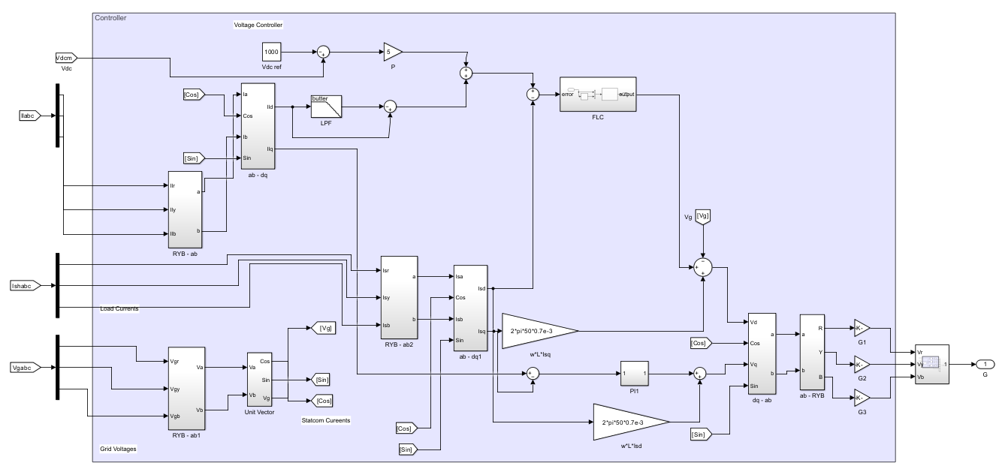
Dstatcom controller
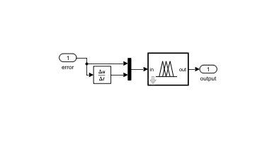
Fuzzy logic controller
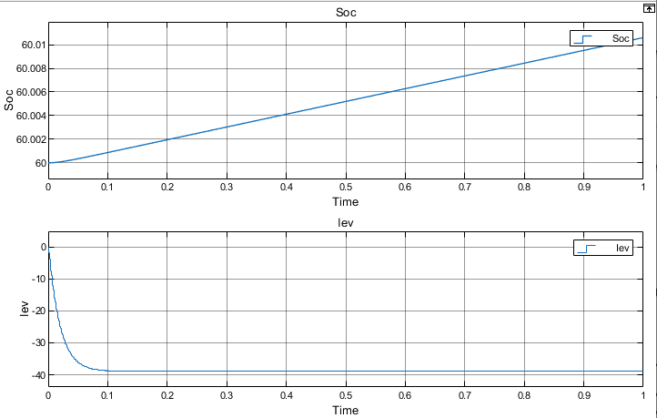
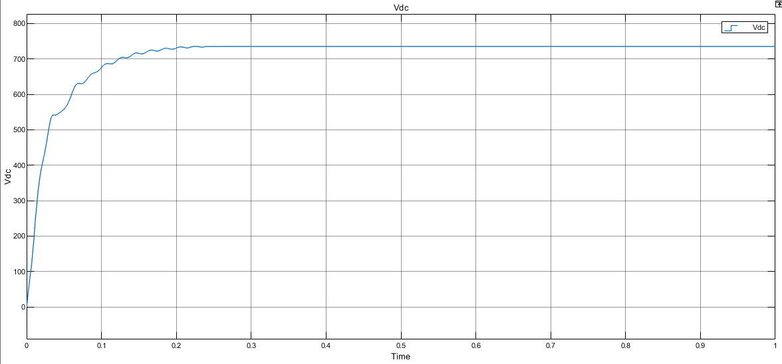

Fig. 7. Variation of EV battery variables for charging operation: (a) battery SOC, (b) battery current with Fuzzy Logic Controller.
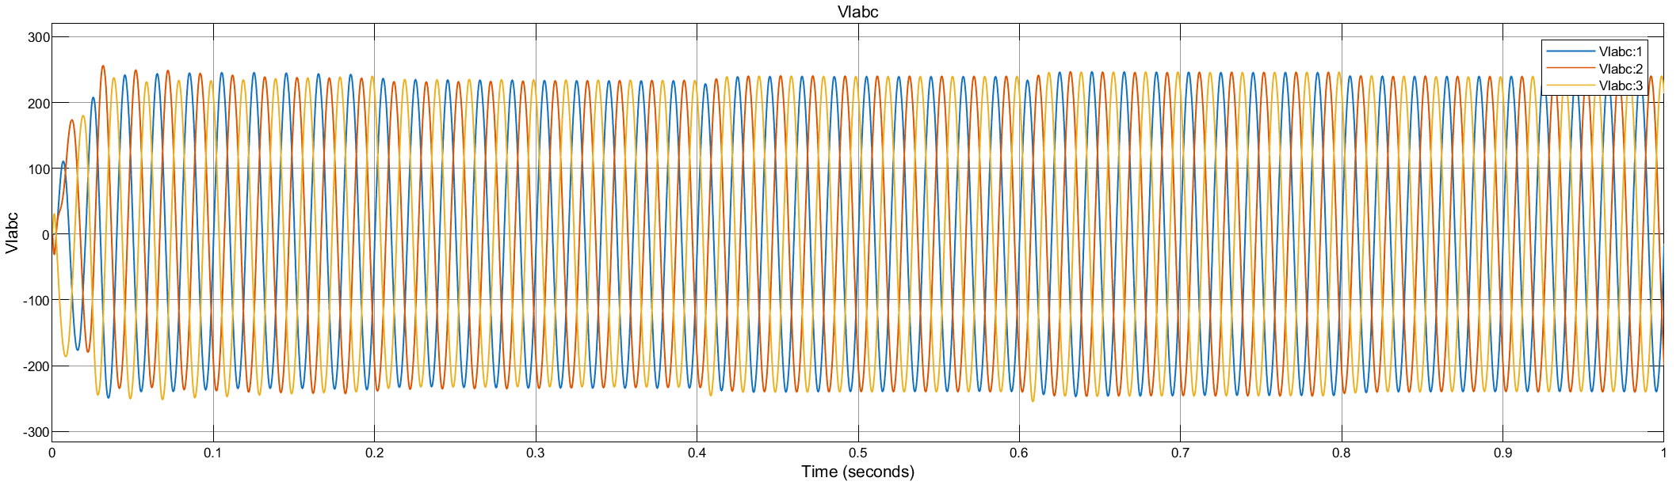
Vlabc
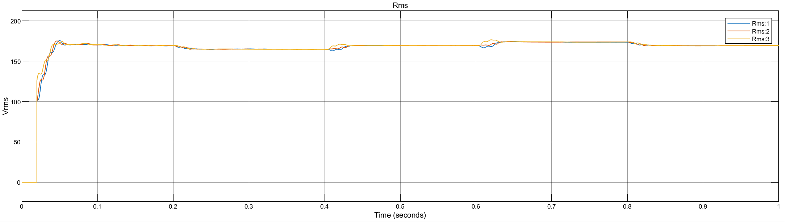
Vlabc
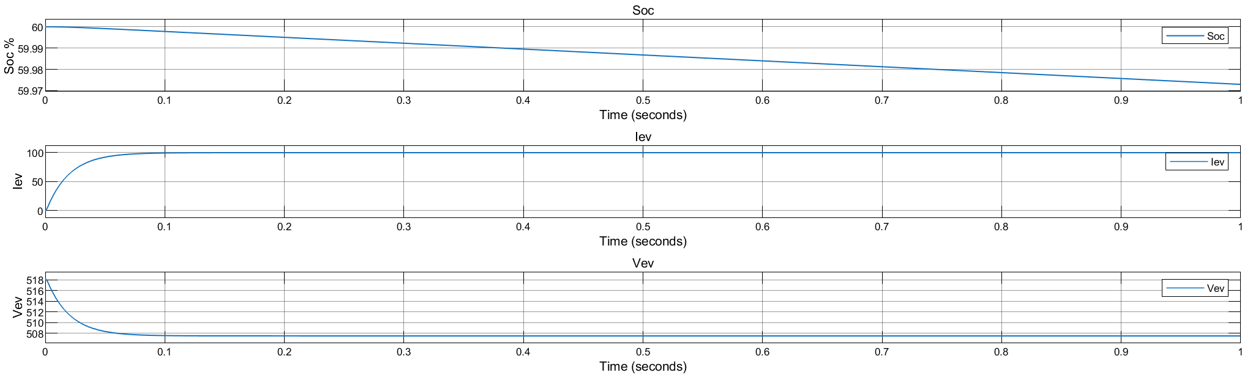
Fig. 13. EV battery results for discharging operation: (a) battery SOC, (b) battery current, and (c) battery voltage with Fuzzy Logic Controller.
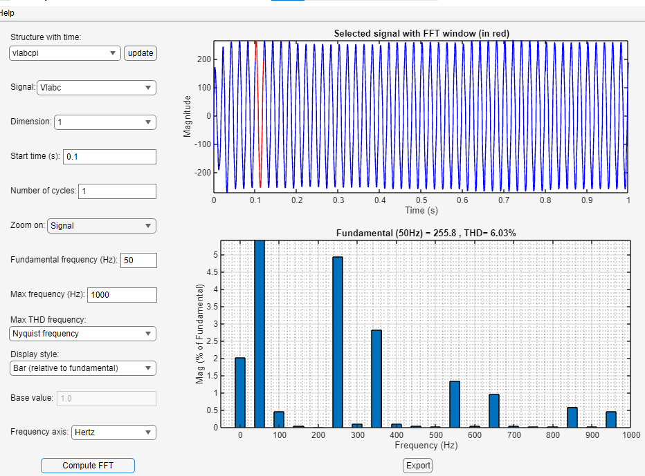
PI controller
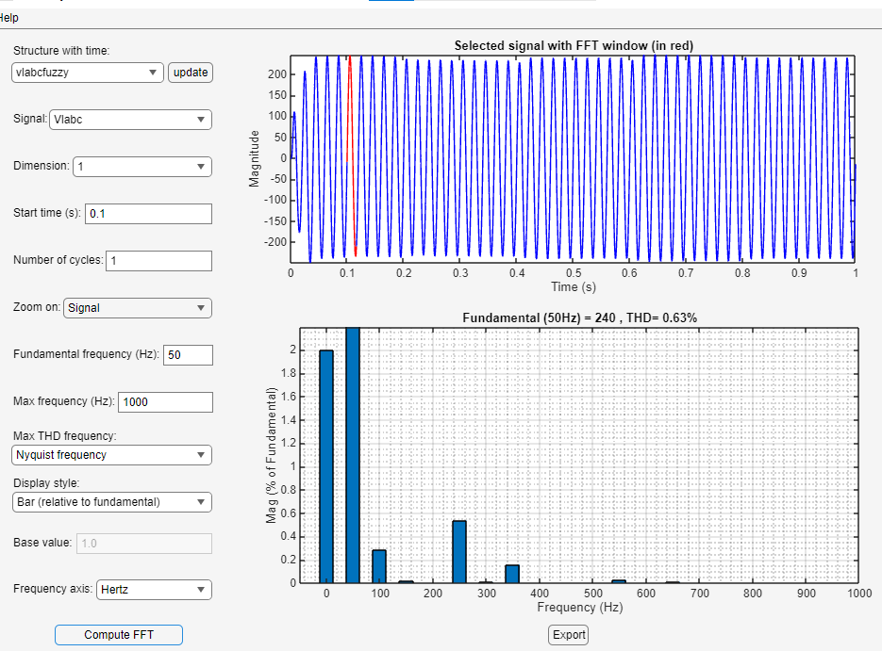
Flc controller

